UNIT 5 - Programming Structure
Structuring a solution in c programming
A robust solution in C is structured using modular programming, separating code into header (.h) files for declarations (the "what") and source (.c) files for definitions (the "how"). This approach makes code reusable, maintainable, and easier to debug.
1. Documentation Section: Comments at the top of the program explaining its purpose, author, and date.
2. Preprocessor Directives (#include): Includes external files like standard libraries (<stdio.h>) and custom header files ("my_module.h").
3. Global Declarations: Global variables and function prototypes that are accessible from anywhere in the program.
4. Main Function: The mandatory entry point for program execution (int main(void)).
5. User-Defined Functions (Subprograms): The implementation of custom functions. For larger projects, these are defined in separate source files.
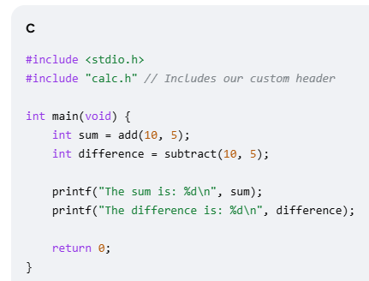
Modules and their functions:
In C programming, the concept of "modules" refers to a software design principle known as modular programming. This approach involves breaking down a large program into smaller, independent, and manageable units called modules. Each module encapsulates a specific set of related functionalities, making the overall program easier to understand, maintain, and reuse.
1. Header Files (.h):
- Header files serve as the interface of a module.
- They contain declarations of functions, global variables, constants, macros, and structure definitions that are intended to be visible and accessible to other parts of the program (client modules).
2. Source Files (.c):
- Source files contain the implementation details of a module.
- They define the actual code for the functions declared in the corresponding header file.
- They can also contain private functions, variables, and data structures that are not exposed to other modules, promoting information hiding and encapsulation.
3. Main Program File (e.g., main.c):
- The main program file acts as the entry point of the application.
- It includes the necessary header files of the modules it intends to use.
- It calls the functions and accesses the variables exposed by those modules through their interfaces.
Benefits of modules:
- Improved Readability
- Enhanced maintainability
- Code Reusability
- Facilitated collaboration
- Easier testing
Local and Global variables:
A variable is a name we give to a memory storage area that our program can then manipulate. We can specify its size and its type depending on the values it will contain (char, int, long).

Local Variables:
Local variables are very short-lived. Declared inside a function, they only exist in RAM as long as the function exists. The second their function ends, they disappear!
In C, a local variable is declared within a function or a block of code. Its scope is limited to that function or block, meaning it can only be accessed and used within that specific region of the program.
The general syntax for declaring a local variable in C is as follows:
datatype variableName;
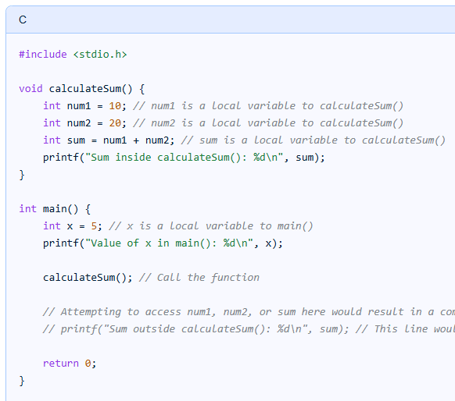
Global variable:
- Global variables are declared outside of any function or block of code, usually at the top of a program or in a separate file.
- They are accessible from any part of the program, including within functions, loops, or other blocks of code.
- Global variables retain their value throughout the lifetime of the program unless explicitly modified or reset.
- Due to their accessibility from anywhere in the program, global variables can introduce unintended side effects and make it harder to understand and debug code, especially in larger programs.
- They are typically used for values that need to be accessed and modified by multiple parts of the program.
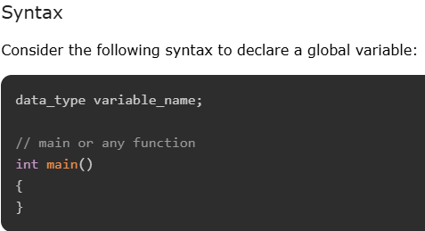
Example of Global Variable in C
The following program shows how global variables are used in a program:

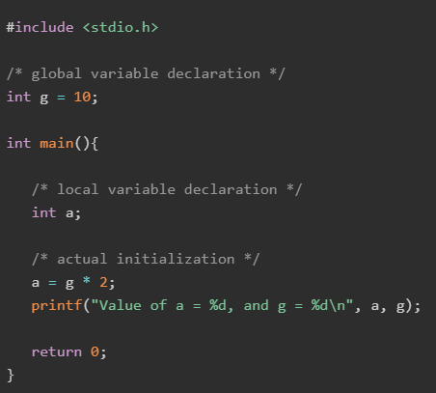
Output
When you run this code, it will produce the following output
Value of a = 20 and g = 10

Parameters: The values that are declared within a function when the function is called are known as an argument. The variables that are defined when the function is declared are known as parameters.
What are Actual Parameters in C?
When we talk about actual parameters in C, we're referring to the arguments that are passed to a function when it is called. These parameters are the real values that are used in a function's execution. To understand this better, let's take a simple example. Consider a function in C that calculates the sum of two numbers:
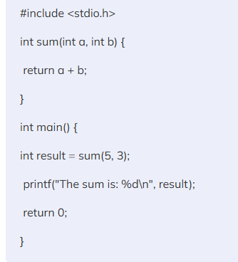
Output
The sum is: 8
In this code snippet, the sum function takes two integers a and b as its parameters. When we call sum(5, 3) in the main function, the values 5 and 3 are the actual parameters. These are the concrete values that the function uses to perform its calculations.
What are Formal Parameters in C?
Formal parameters are the variables found in the function definition. They act as placeholders for the values that will be passed to the function. When a function is called, the actual parameters' values are assigned to these formal parameters. Let's continue with our previous example to understand this concept better:
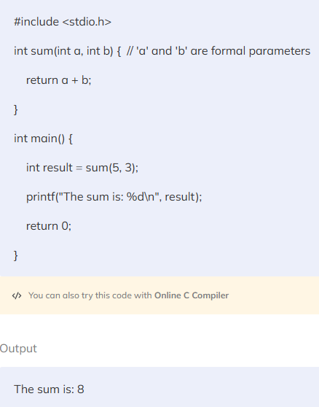
In the sum function definition, int a and int b are formal parameters. They don't have any values themselves; instead, they are placeholders that receive the actual parameters' values, which in our case are 5 and 3 from the function call sum(5, 3).
………………………………………………………………………….
Return values: to be continued

